WEEK 4: ASP.NET Core 8.0 Web API
1.WebAPI HandsOn
RESTFUL (Representational State Transfer) Web Service
- It is a stateless, resource based service uses HTTP verbs.
Web Service
- Exposes RESTful services via HTTP and supports multiple data formats (JSON, XML).
Microservices:
- It is small, independent, focused services, loosely coupled and scalable.
HTTPRequest: Incoming data from client.
HTTPResponse: Outgoing data to client.
ActionVerbs:
- [HttpGet]: Read data
- [HttpPost]: Create
- [HttpPut]: Update
- [HttpDelete]: Delete
HTTP Status Codes:
Ok() - 200
BadRequest() – 400
Unauthorized() – 401
StatusCode(500) – Internal Server Error
Configuration Files in Web API:
- .NET Core: Startup.cs, appSettings.json, launchSettings.json
- .NET 4.5: WebApi.config, Route.config

1.First Web API using .Net Core
EmployeeController.cs
using Microsoft.AspNetCore.Mvc;
using System.Collections.Generic;
namespace FirstWebAPI.Controllers
{
[ApiController]
[Route("api/[controller]")]
public class EmployeeController : ControllerBase
{
private static readonly List<string> Employees = new()
{
"Kaviin", "Kaushik", "Kavirajan"
};
[HttpGet]
public ActionResult<IEnumerable<string>> Get()
{
return Employees;
}
[HttpGet("{id}")]
public ActionResult<string> Get(int id)
{
if (id < 0 || id >= Employees.Count)
return NotFound("Employee not found");
return Employees[id];
}
[HttpPost]
public IActionResult Post([FromBody] string name)
{
Employees.Add(name);
return Ok("Employee added successfully");
}
[HttpPut("{id}")]
public IActionResult Put(int id, [FromBody] string name)
{
if (id < 0 || id >= Employees.Count)
return NotFound("Employee not found");
Employees[id] = name;
return Ok("Employee updated successfully");
}
[HttpDelete("{id}")]
public IActionResult Delete(int id)
{
if (id < 0 || id >= Employees.Count)
return NotFound("Employee not found");
Employees.RemoveAt(id);
return Ok("Employee deleted successfully");
}
}
}
OUTPUT:
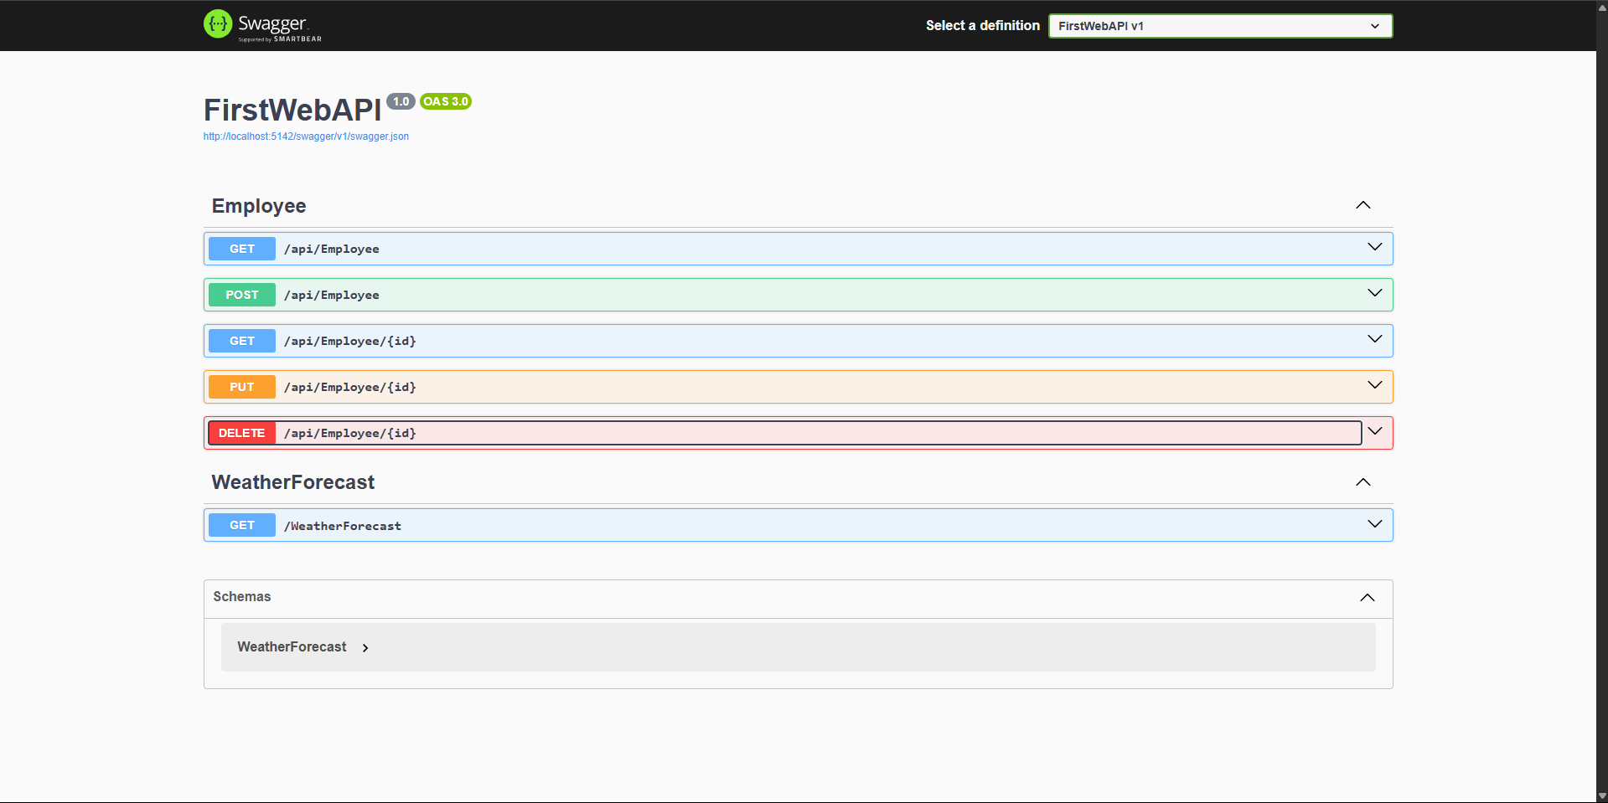

2.WebApi HandsOn

1. Web Api using .Net core with Swagger
Program.cs
using Microsoft.OpenApi.Models;
var builder = WebApplication.CreateBuilder(args);
builder.Services.AddControllers();
builder.Services.AddEndpointsApiExplorer();
builder.Services.AddSwaggerGen(c =>
{
c.SwaggerDoc("v1", new OpenApiInfo
{
Title = "Swagger Demo",
Version = "v1",
Description = "Employee API Demo",
Contact = new OpenApiContact { Name = "John Doe", Email = "john@example.com" }
});
});
var app = builder.Build();
app.UseSwagger();
app.UseSwaggerUI(c =>
{
c.SwaggerEndpoint("/swagger/v1/swagger.json", "Swagger Demo v1");
});
app.UseHttpsRedirection();
app.UseAuthorization();
app.MapControllers();
app.Run();
Output: 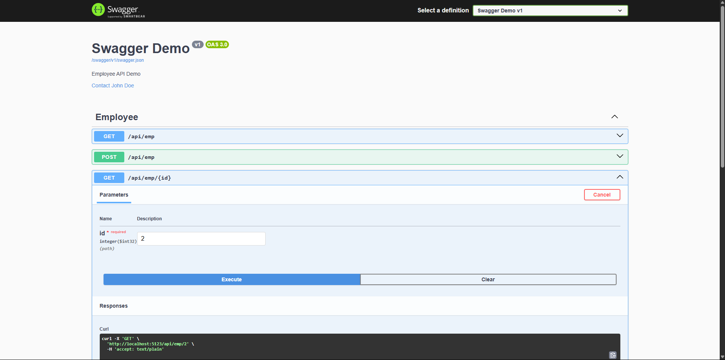
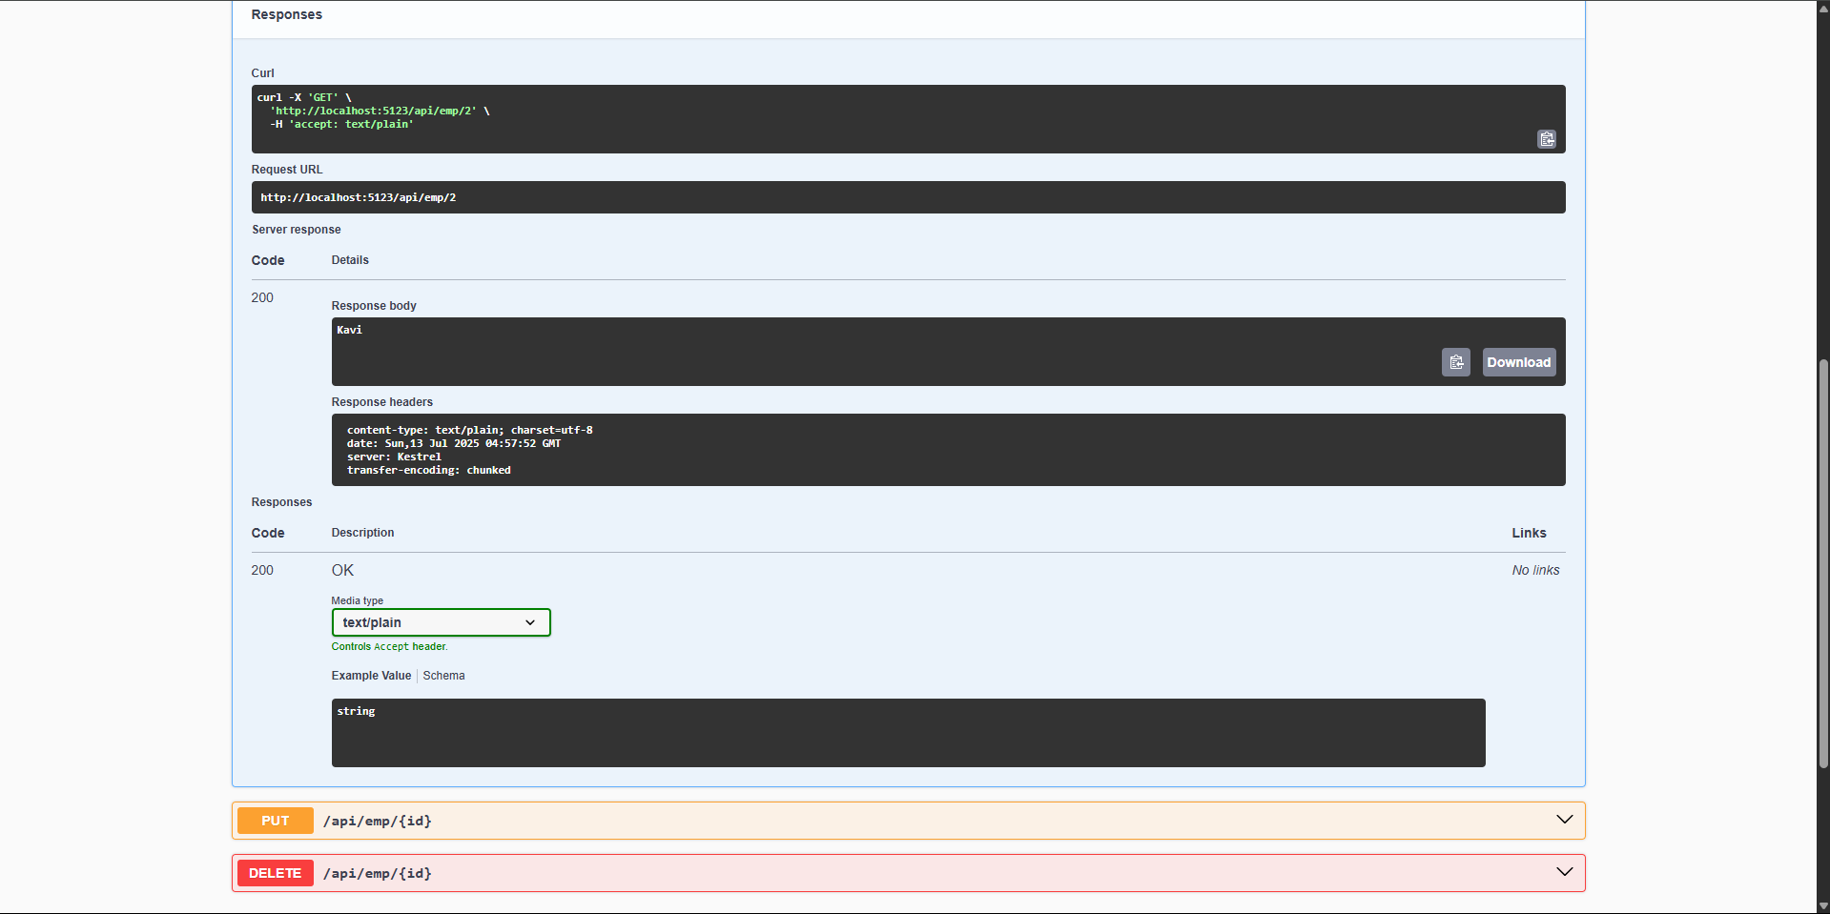

2.Using Postman Tool
Output:
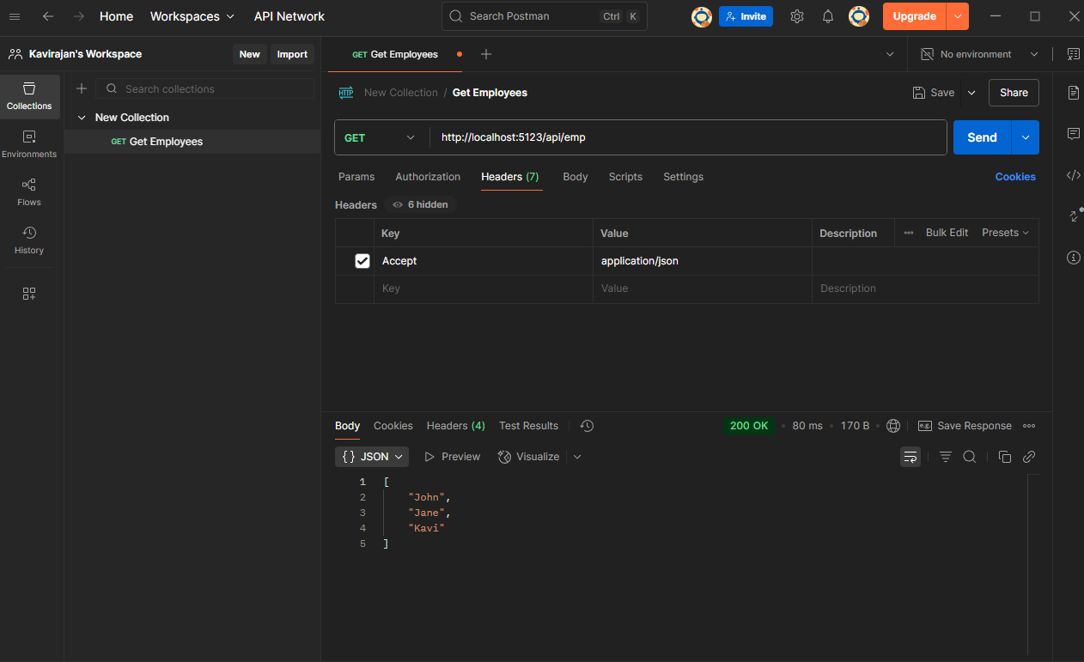
3.Modify the Controller name in the Route attribute of the Employee controller to ‘Emp’ and check its access thru POSTMAN
using Microsoft.AspNetCore.Mvc;
[ApiController]
[Route("api/emp")]
public class EmployeeController : ControllerBase
{
private static readonly List<string> Employees = new() { "Kaviin", "Kaushik", "Kavirajan" };
[HttpGet]
public ActionResult<IEnumerable<string>> Get() => Employees;
[HttpGet("{id}")]
public ActionResult<string> Get(int id) =>
(id >= 0 && id < Employees.Count) ? Employees[id] : NotFound();
[HttpPost]
public IActionResult Post([FromBody] string name)
{
Employees.Add(name);
return Ok("Added");
}
[HttpPut("{id}")]
public IActionResult Put(int id, [FromBody] string name)
{
if (id < 0 || id >= Employees.Count) return NotFound();
Employees[id] = name;
return Ok("Updated");
}
[HttpDelete("{id}")]
public IActionResult Delete(int id)
{
if (id < 0 || id >= Employees.Count) return NotFound();
Employees.RemoveAt(id);
return Ok("Deleted");
}
}
Output: 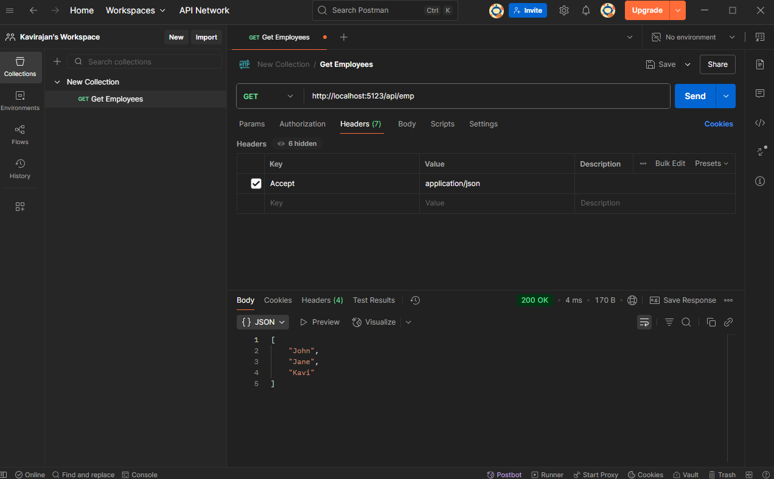

3. WebAPI HandsOn
Employee.cs
using System;
using System.Collections.Generic;
namespace FirstWebAPI.Models
{
public class Employee
{
public int Id { get; set; }
public string Name { get; set; }
public int Salary { get; set; }
public bool Permanent { get; set; }
public Department Department { get; set; }
public List<Skill> Skills { get; set; }
public DateTime DateOfBirth { get; set; }
}
public class Department
{
public int Id { get; set; }
public string DeptName { get; set; }
}
public class Skill
{
public int Id { get; set; }
public string SkillName { get; set; }
}
}
EmployeeController.cs
using FirstWebAPI.Models;
using Microsoft.AspNetCore.Mvc;
using Microsoft.AspNetCore.Mvc.Filters;
using YourNamespace.Filters;
namespace YourNamespace.Controllers
{
[ApiController]
[Route("api/[controller]")]
[ServiceFilter(typeof(CustomAuthFilter))]
public class EmployeeController : ControllerBase
{
private readonly List<Employee> _employees;
public EmployeeController()
{
_employees = GetStandardEmployeeList();
}

private List<Employee> GetStandardEmployeeList() => new()
{
new Employee
{
Id = 1,
Name = "Kavi Rajan",
Salary = 40000,
Permanent = true,
Department = new Department { Id = 1, DeptName = "IT" },
Skills = new List<Skill> { new Skill { Id = 1, SkillName = "C#" } },
DateOfBirth = new DateTime(2000, 1, 1)
}
};
[HttpGet("GetStandard")]
[ProducesResponseType(200)]
[ProducesResponseType(500)]
public ActionResult<List<Employee>> GetStandard()
{
return Ok(_employees);
}
[HttpPost]
public IActionResult AddEmployee([FromBody] Employee emp)
{
_employees.Add(emp);
return Ok(emp);
}
}
}
CustomAuthFilter.cs
using Microsoft.AspNetCore.Mvc;
using Microsoft.AspNetCore.Mvc.Filters;
using System.Linq;
namespace YourNamespace.Filters
{
public class CustomAuthFilter : ActionFilterAttribute
{
public override void OnActionExecuting(ActionExecutingContext context)
{
var authHeader = context.HttpContext.Request.Headers["Authorization"].FirstOrDefault();
if (string.IsNullOrEmpty(authHeader))
{
context.Result = new BadRequestObjectResult("Invalid request - No Auth token");
return;
}
if (!authHeader.StartsWith("Bearer"))
{
context.Result = new BadRequestObjectResult("Invalid request - Token present but Bearer unavailable");
return;
}
base.OnActionExecuting(context);
}
}
}
CustomExceptionFilter.cs
using Microsoft.AspNetCore.Mvc;
using Microsoft.AspNetCore.Mvc.Filters;
using System;
using System.IO;
namespace YourNamespace.Filters
{
public class CustomExceptionFilter : IExceptionFilter
{
public void OnException(ExceptionContext context)
{
var exceptionMessage = $"Exception: {context.Exception.Message} | Date: {DateTime.Now}";
File.AppendAllText("logs.txt", exceptionMessage + Environment.NewLine);
context.Result = new ObjectResult("An error occurred. Please try again later.")
{
StatusCode = 500
};
}
}
}
Output:
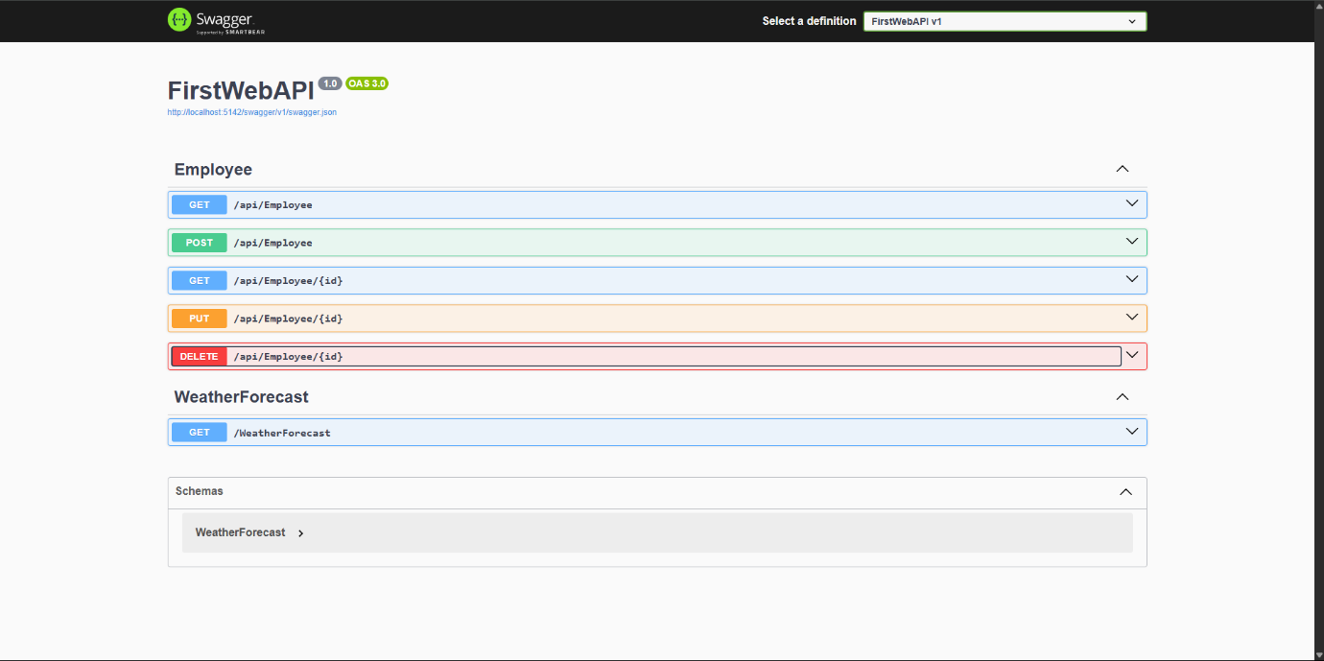

4.WebApi HandsOn
Testing with Swagger
- Open https://localhost:/swagger
- Try POST, PUT, DELETE operations directly from the UI.
- Swagger will auto-generate input form for your Product model.
Testing with Postman
- Create:
  - Type: POST
  - URL: https://localhost:/api/products
  - Body → raw → JSON:
Program.cs
var builder = WebApplication.CreateBuilder(args);
builder.Services.AddControllers();
builder.Services.AddEndpointsApiExplorer();
builder.Services.AddSwaggerGen();
var app = builder.Build();
if (app.Environment.IsDevelopment())
{
app.UseSwagger();
app.UseSwaggerUI();
}
app.UseHttpsRedirection();
app.UseAuthorization();
app.MapControllers();
app.Run();
EmployeeController.cs
using Microsoft.AspNetCore.Mvc;
using EmployeeCrudApi.Models;
namespace EmployeeCrudApi.Controllers
{
[ApiController]
[Route("api/[controller]")]
public class EmployeeController : ControllerBase
{
private static readonly List<Employee> Employees = new()
{
new Employee
{
Id = 1,
Name = "Kavi",
Salary = 60000,
Permanent = true,
Department = new Department { Id = 1, Name = "IT" },
DateOfBirth = new DateTime(1999, 01, 15)
},
new Employee
{
Id = 2,
Name = "Rajan",
Salary = 45000,
Permanent = false,
Department = new Department { Id = 2, Name = "HR" },
DateOfBirth = new DateTime(2000, 04, 10)
}
};
[HttpPut("{id}")]
public ActionResult<Employee> UpdateEmployee(int id, [FromBody] Employee updated)
{
if (id <= 0)
return BadRequest("Invalid employee id");
var emp = Employees.FirstOrDefault(e => e.Id == id);
if (emp == null)
return BadRequest("Invalid employee id");
emp.Name = updated.Name;
emp.Salary = updated.Salary;
emp.Permanent = updated.Permanent;
emp.Department = updated.Department;
emp.DateOfBirth = updated.DateOfBirth;
return Ok(emp);
}
[HttpDelete("{id}")]
public IActionResult DeleteEmployee(int id)
{
if (id <= 0)
return BadRequest("Invalid employee id");
var emp = Employees.FirstOrDefault(e => e.Id == id);
if (emp == null)
return NotFound("Employee not found");
Employees.Remove(emp);
return Ok($"Employee with ID {id} deleted successfully");
}
}
}
Employee.cs
using System;
using System.Collections.Generic;
namespace EmployeeCrudApi.Models
{
public class Employee
{
public int Id { get; set; }
public string Name { get; set; }
public int Salary { get; set; }
public bool Permanent { get; set; }
public Department Department { get; set; }
public DateTime DateOfBirth { get; set; }
}
}
Department.cs
namespace EmployeeCrudApi.Models
{
public class Department
{
public int Id { get; set; }
public string Name { get; set; }
}
}

WebApi Crud Operation: PUT Method
Using Swagger:

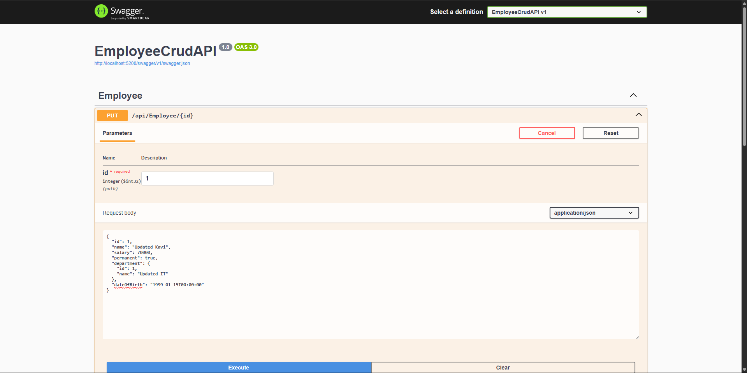
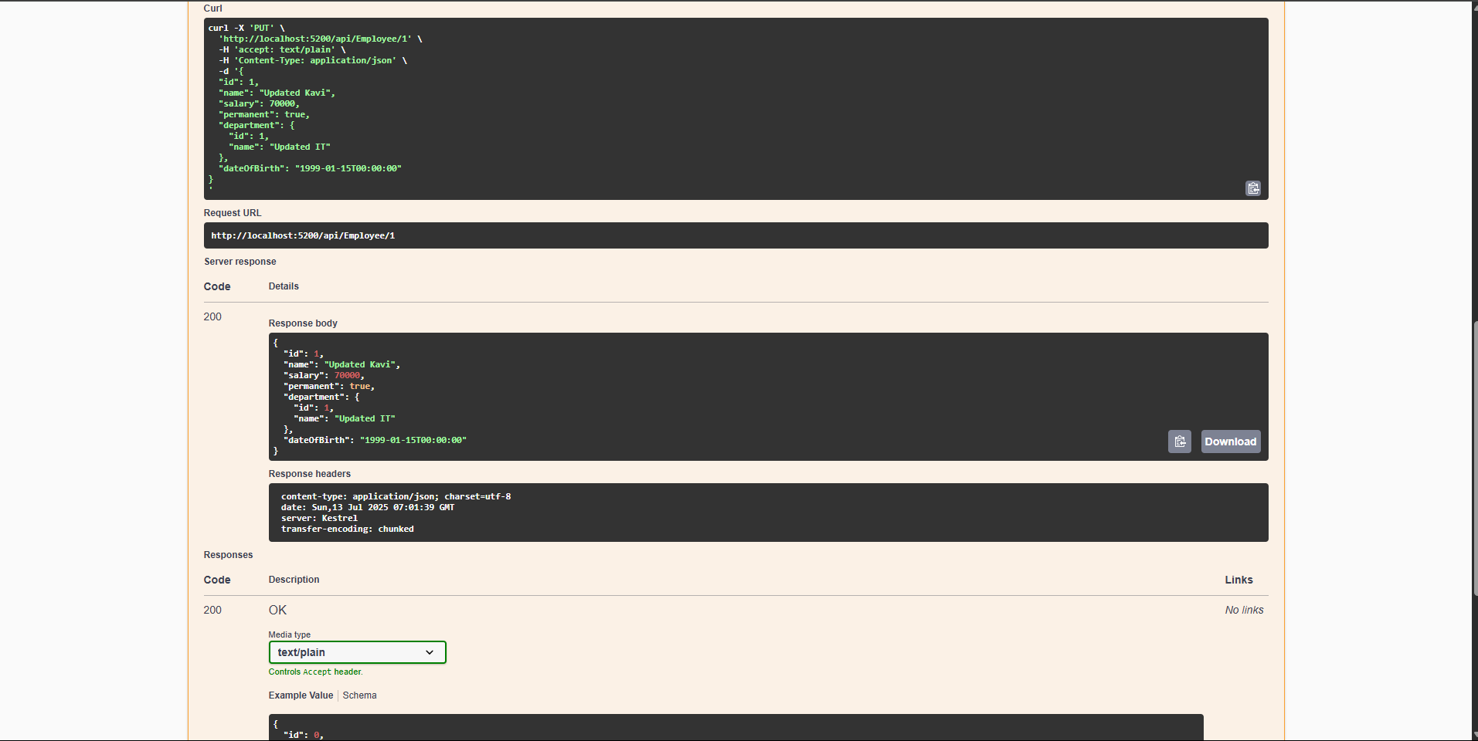

Using Postman:
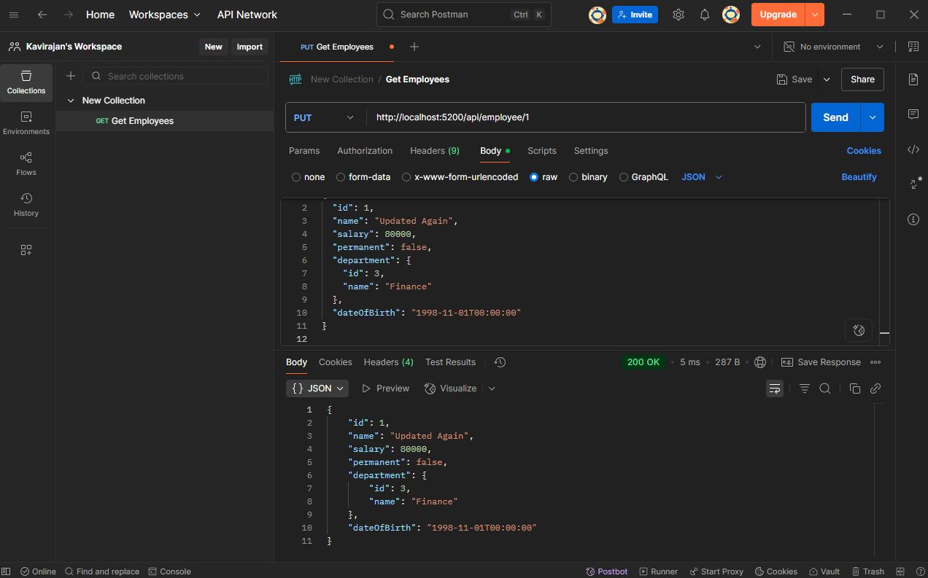
Crud Operation: Delete Method
Using Swagger:
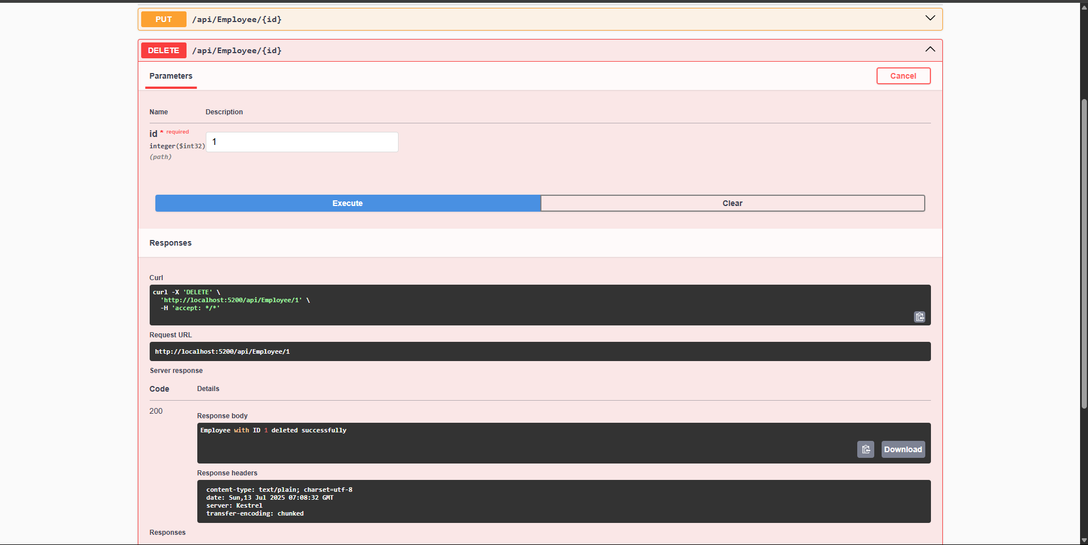

Using Postman:
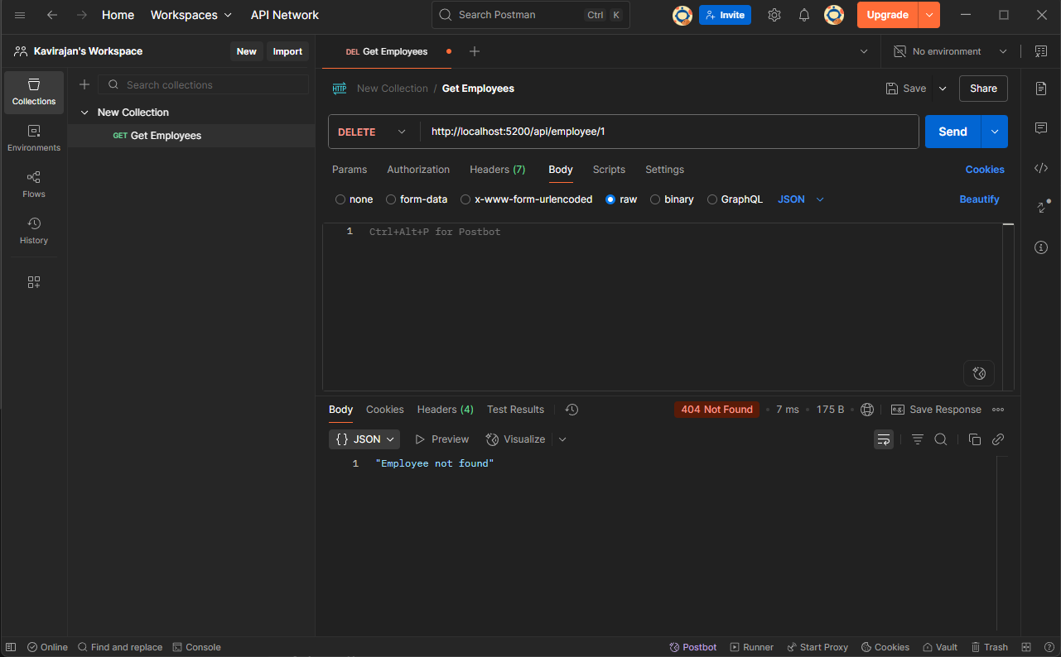

5.JSON Web Token(JWT)
CORS in WebAPI:
CORS (Cross-Origin Resource Sharing) allows your Web API to be accessed from a different domain. By default, browsers block cross-origin requests for security.
Web API Security with JWT Authentication
- JWT (JSON Web Token): Compact token with claims.
- Bearer Token: Sent in Authorization header (Bearer eyJhbGciOi...).
- Authorize: Restricts access to authenticated users.
- AllowAnonymous: Used for login/token generation endpoint.

Program.cs
using Microsoft.AspNetCore.Authentication.JwtBearer;
using Microsoft.IdentityModel.Tokens;
using System.Text;
using System.Security.Claims;
using Microsoft.OpenApi.Models;
var builder = WebApplication.CreateBuilder(args);
builder.Services.AddControllers();
builder.Services.AddCors(options =>
{
options.AddPolicy("AllowAll", policy =>
{
policy.AllowAnyOrigin()
.AllowAnyMethod()
.AllowAnyHeader();
});
});
builder.Services.AddEndpointsApiExplorer();
builder.Services.AddSwaggerGen(c =>
{
c.SwaggerDoc("v1", new() { Title = "JWT Auth API", Version = "v1" });
c.AddSecurityDefinition("Bearer", new OpenApiSecurityScheme
{
Description = "JWT Authorization header using the Bearer scheme (Example: 'Bearer token')",
Name = "Authorization",
In = ParameterLocation.Header,
Type = SecuritySchemeType.ApiKey,
Scheme = "Bearer"
});
c.AddSecurityRequirement(new OpenApiSecurityRequirement
{
{
new OpenApiSecurityScheme
{
Reference = new OpenApiReference
{
Type = ReferenceType.SecurityScheme,
Id = "Bearer"
}
},
new string[] {}
}
});
});
var key = Encoding.UTF8.GetBytes("mysuperdupersecret");
builder.Services.AddAuthentication(JwtBearerDefaults.AuthenticationScheme)
.AddJwtBearer(options =>
{
options.TokenValidationParameters = new()
{
ValidateIssuer = true,
ValidateAudience = true,
ValidateLifetime = true,
ValidateIssuerSigningKey = true,
ValidIssuer = "mySystem",
ValidAudience = "myUsers",
IssuerSigningKey = new SymmetricSecurityKey(key)
};
});
builder.Services.AddAuthorization();
var app = builder.Build();
app.UseCors("AllowAll");
app.UseSwagger();
app.UseSwaggerUI();
app.UseAuthentication();
app.UseAuthorization();
app.MapControllers();
app.Run();
Models/Employee.cs
namespace JwtAuthApiDemo.Models
{
public class Employee
{
public int Id { get; set; }
public string Name { get; set; }
}
}
Controllers/AuthController.cs
using Microsoft.AspNetCore.Mvc;
using Microsoft.IdentityModel.Tokens;
using System.IdentityModel.Tokens.Jwt;
using System.Security.Claims;
using System.Text;
namespace JwtAuthApiDemo.Controllers
{
[ApiController]
[Route("api/[controller]")]
public class AuthController : ControllerBase
{
[HttpGet("token")]
[AllowAnonymous]
public IActionResult GetToken()
{
var securityKey = new SymmetricSecurityKey(Encoding.UTF8.GetBytes("mysuperdupersecret"));
var credentials = new SigningCredentials(securityKey, SecurityAlgorithms.HmacSha256);
var claims = new[]
{
new Claim(ClaimTypes.Name, "User1"),
new Claim(ClaimTypes.Role, "Admin"),
new Claim("UserId", "1")
};
var token = new JwtSecurityToken(
issuer: "mySystem",
audience: "myUsers",
claims: claims,
expires: DateTime.Now.AddMinutes(2),
signingCredentials: credentials);
return Ok(new { token = new JwtSecurityTokenHandler().WriteToken(token) });
}
}
}
Controllers/EmployeeControler.cs
using JwtAuthApiDemo.Models;
using Microsoft.AspNetCore.Authorization;
using Microsoft.AspNetCore.Mvc;
namespace JwtAuthApiDemo.Controllers
{
[ApiController]
[Route("api/[controller]")]
[Authorize(Roles = "Admin,POC")]
public class EmployeeController : ControllerBase
{
private static List<Employee> Employees = new()
{
new Employee { Id = 1, Name = "Kavi" },
new Employee { Id = 2, Name = "Rajan" }
};
[HttpGet]
public ActionResult<List<Employee>> GetAll()
{
return Employees;
}
[HttpPost]
public IActionResult Create([FromBody] Employee emp)
{
Employees.Add(emp);
return Ok("Created");
}
[HttpPut("{id}")]
public IActionResult Update(int id, [FromBody] Employee emp)
{
var existing = Employees.FirstOrDefault(e => e.Id == id);
if (existing == null) return BadRequest("Invalid employee id");

existing.Name = emp.Name;
return Ok(existing);
}
[HttpDelete("{id}")]
public IActionResult Delete(int id)
{
var existing = Employees.FirstOrDefault(e => e.Id == id);
if (existing == null) return BadRequest("Invalid employee id");

Employees.Remove(existing);
return Ok("Deleted");
}
}
}
Output:
Using Swagger:

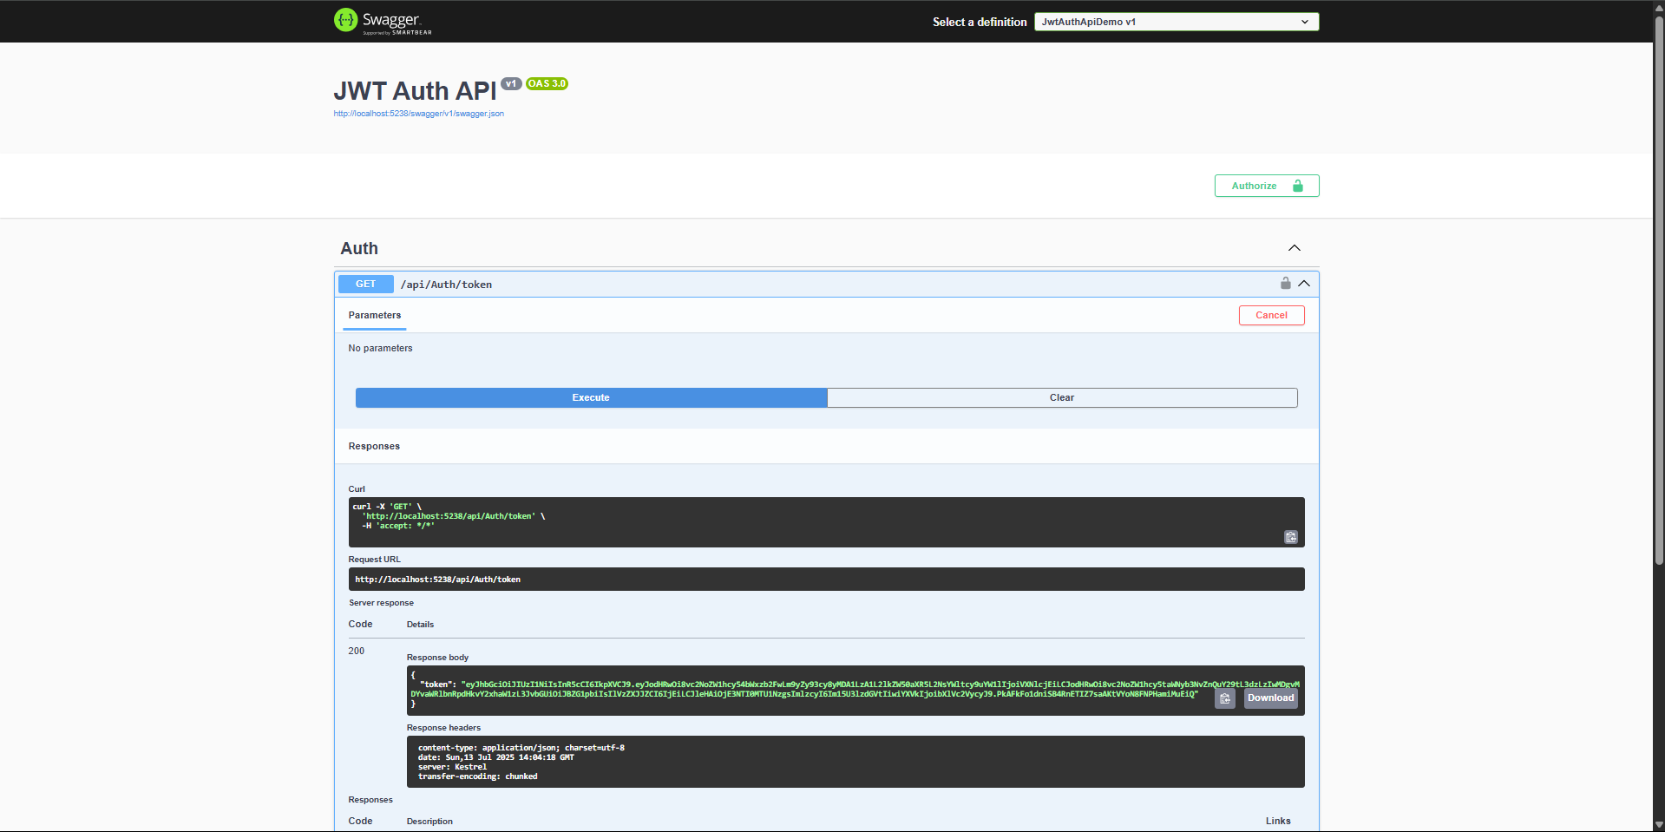
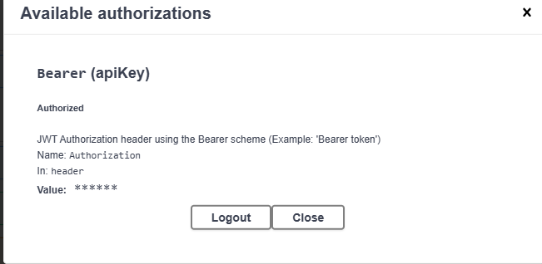

Using Postman:
